U2 Topic 4 Multicellular Animals

- in animals, waste such as carbon dioxide, water, nitrogenous compounds and salts are excreted; different types of nitrogenous wastes are produced by the breakdown of proteins; most aquatic animals excrete nitrogenous wastes directly into their surroundings; terrestrial animals require specialised mechanisms

Excretion
Proteins
You may recall, from Topic 2, that the elements carbon (C), hydrogen (H), oxygen (O) and nitrogen (N) combine to form amino acids which are the base units of proteins.

The Breakdown of Proteins
Unlike plants, animals cannot produce their own food.
Animals can store a ready supply of fats and carbohydrates but are unable to store dietary protein efficiently.
Most animal protein is ‘stored’ as skeletal muscle or used in structural tissues such as skin, bone, and organs including the kidneys and liver. Muscle tissue can be broken down to release certain amino acids.

Proteins are the dietary source of amino acids, however, amino acids cannot be conveniently stored. Excess protein [amino acids] can be converted into fat and stored in fat deposits, or converted to glucose for energy by the process of gluconeogenesis.
Oxidative deamination occurs under aerobic conditions in the liver where amino acids are converted by the removal of the amine group.

Excess amino acids are transported to the liver and oxidised [broken down] in a process called deamination.

Deamination is the removal of the amine group NH2 from each amino acid to form ammonia. Ammonia is highly toxic and the liver converts the ammonia to the less toxic nitrogenous waste urea.

Nitrogenous Wastes
Different types of nitrogenous wastes are produced during the breakdown of proteins; these include ammonia, urea and uric acid.
Ammonia is highly toxic and needs to be excreted immediately. Many aquatic animals, including fish, produce and excrete their nitrogenous waste in the form of ammonia.
Uric acid is a non-toxic and insoluble form of nitrogenous waste produced by egg laying animals such as birds and reptiles.
Urea is less toxic and can be temporarily stored in the body. Specialised mechanisms for the production and storage of urea includes the urinary system.
The Urinary System
Urea produced during deamination is transported in the blood from the liver to the kidneys. The kidneys are part of the urinary or excretory system in all vertebrates.
Excretory system
- the nephron
- formation of urine and excretion of wastes by the urinary system
- deamination of amino acids in the liver

Many of the waste products of metabolism end up in the blood. These waste products include:
- urea
Metabolic wastes are wastes produced by the body as it undergoes its chemical reactions.
They include: carbon dioxide, urea and acids.
- excess salts
- excess water.

The function of the urinary system is to remove these wastes from the blood and excrete them in the urine.
The urinary system consists of:
- two kidneys
- two ureters
- the urinary bladder
- the urethra.

Label the following diagram of the urinary system. See figure 12.31 page 408
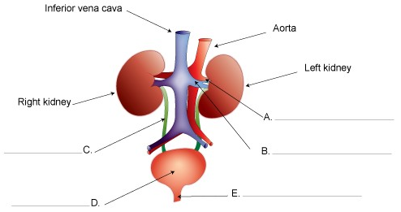
Each kidney is made up of approximately one million microscopic structures called nephrons. The nephrons filter the blood and reabsorb particular molecules from the filtrate back into the blood.

The nephron consists of a closed tube with a cup-like end called the glomerular capsule or Bowman’s capsule. The Bowman’s capsule encloses a network of capillaries called the glomerulus. The tube leaving the Bowman’s capsule is convoluted (coiled) and is known as the proximal convoluted tubule.

The convoluted tubule joins to a U-shaped section called the loop of Henle which joins to the distal convoluted tubule and then forms the collecting duct. The collecting duct receives urine for several nephrons and empties it into the pelvis of the kidney.

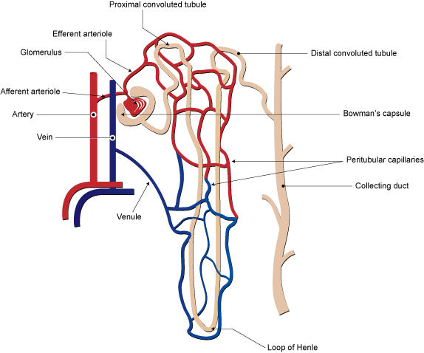
The nephron shown below is the functional unit of the kidney

Summarise the function of each part of the nephron. Use the table on pages 409-410 to help.
Name/structure | Main function
Glomerulus
Bowmans capsule
Proximal convoluted tubule
Loop of Henle
Distal convoluted tubule
Collecting duct

Answers

A. Renal artery B. Renal vein C. Ureter
D. Bladder E. Urethra

